EXPT NO: 2 | COMPARATIVE STUDY OF ACTIVATION FUNCTIONS AND OPTIMIZATION ALGORITHMS IN DEEP LEARNING
DATE:

Midhun P 24BAD069

PRE-LAB QUESTIONS (PROVIDE BRIEF ANSWERS TO THE FOLLOWING QUESTIONS)

- What is the purpose of an activation function in an Artificial Neural Network?

An activation function decides whether a neuron should be activated based on its input.
It introduces non-linearity into the neural network, allowing the model to learn complex relationships in data.Without activation functions, multiple neural-network layers would behave like a single linear transformation.
Common activation functions include Sigmoid, Tanh, and ReLU.
Different activation functions have different output ranges and gradient behaviors.
The choice of activation function can therefore affect the speed and quality of model training.

- Differentiate between the Sigmoid, Tanh, and ReLU activation functions based on their output range and mathematical properties.

Sigmoid produces values between 0 and 1 and is useful when an output needs to represent a probability.
Tanh produces values between -1 and 1 and is centered around zero, unlike Sigmoid.
Both Sigmoid and Tanh can suffer from saturation, where their gradients become very small. ReLU outputs zero for negative inputs and the input itself for positive values.
ReLU is computationally simple and generally allows faster training in deep networks.
Therefore, ReLU is commonly used in hidden layers, while Sigmoid can be useful for binary-output problems.

- Why is an optimization algorithm required during neural network training?

An optimization algorithm is used to adjust the weights and biases of a neural network during training.Its main purpose is to reduce the value of the model's loss function.
The algorithm uses information from gradients to determine how the model parameters should change.Different optimizers use different strategies for controlling the direction and size of these updates.
Examples include SGD, Momentum, RMSProp, and Adam.
A suitable optimizer can improve convergence speed and help the model reach good performance efficiently.

- What is the difference between Batch Gradient Descent, Stochastic Gradient Descent (SGD), and Mini-Batch Gradient Descent?
Batch Gradient Descent calculates the gradient using the entire training dataset before updating the model parameters.It can provide stable updates but may require considerable computation for large datasets.
Stochastic Gradient Descent (SGD) updates the parameters using one training example at a time.This makes updates faster but can cause more fluctuation during the optimization process.
Mini-Batch Gradient Descent uses a small group of training examples for each update.
It provides a practical balance between the stability of batch training and the speed of stochastic updates.

- Explain the role of Google Colab and GitHub in deep learning experiment management.
Google Colab provides a cloud-based environment where Python and deep-learning libraries can be executed without requiring a powerful local computer.
It can provide access to hardware resources such as GPUs for suitable workloads.
Colab also makes it convenient to create and run Jupyter-style notebooks interactively.
GitHub is used for storing source code, notebooks, and other project files in a repository.
It provides version control through commits, making it possible to track changes made during development.Together, these tools can support experiment execution, organization, collaboration, and reproducibility.

AIM
To analyze the impact of different activation functions and optimization algorithms on the performance of Artificial Neural Networks (ANNs) and to learn best practices for managing deep learning experiments using cloud-based tools and version control.

SOFTWARE REQUIREMENTS
- Python
- TensorFlow or PyTorch
- Google Colab
- GitHub
- Matplotlib

OBJECTIVES
Students will be able to:
- Understand the role of activation functions in neural networks.
- Visualize and compare commonly used activation functions.
- Evaluate the performance of different activation functions in ANN models.
- Analyze various gradient-based optimization algorithms.
- Compare optimizer convergence and model accuracy.
- Learn experiment management using Google Colab, Google Drive, and GitHub.
- Maintain reproducible deep learning experiments using version control.

Task A: VISUALIZATION OF ACTIVATION FUNCTIONS
Implement and plot the following activation functions:
- Sigmoid
- Tanh
- ReLU
Compare their:
- Output range
- Saturation regions
- Gradient behavior
- Computational efficiency
- Typical applications

(CODE: CONATAINS STUDENT ROLL NOS
SCREENSHOT OF CODE
SCREENSHOT OF OUTPUT)
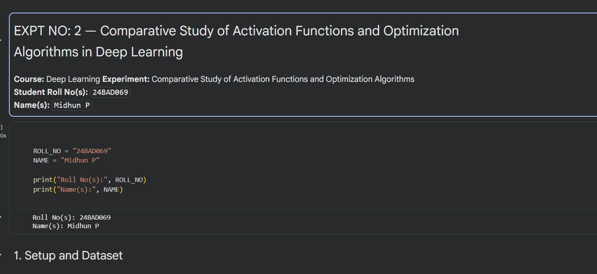
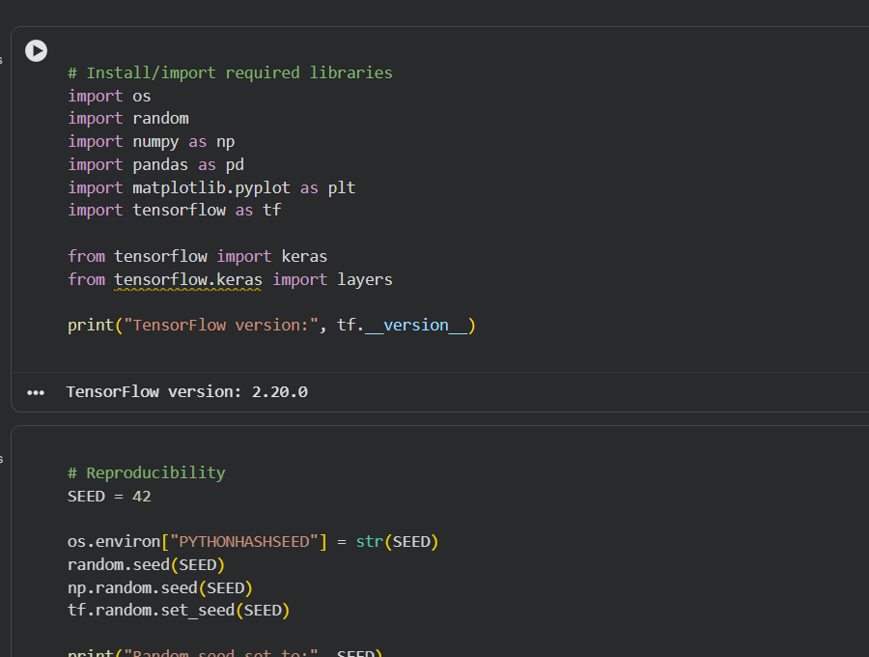

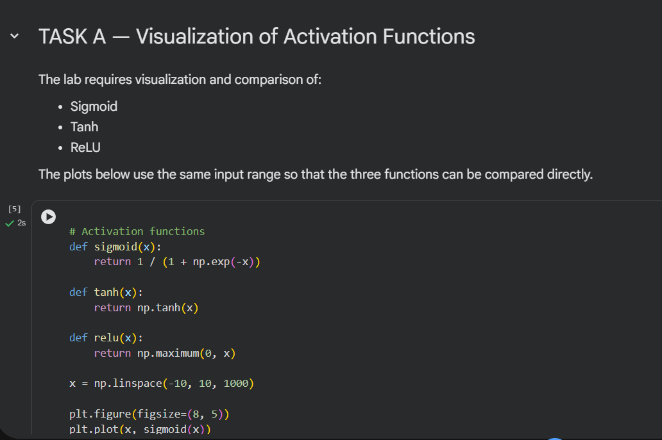

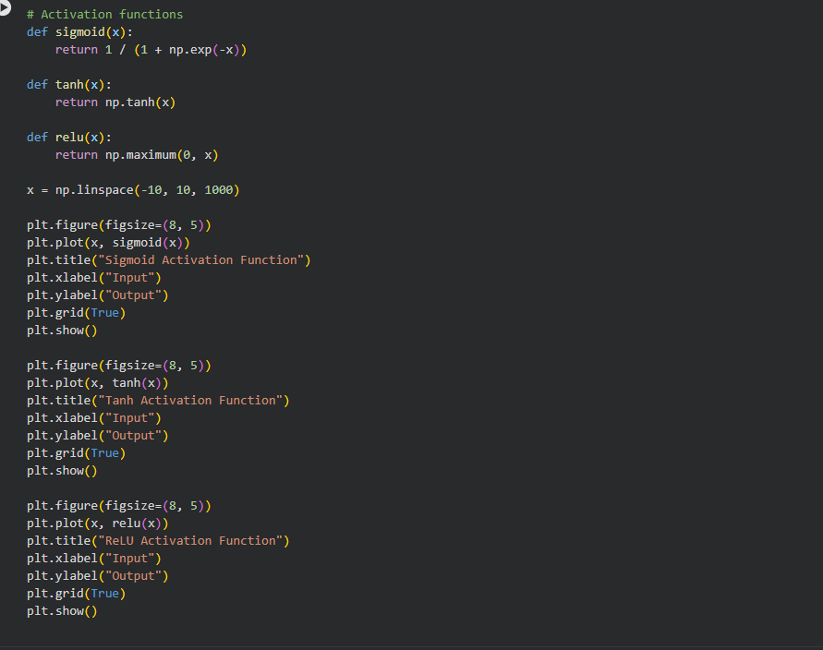
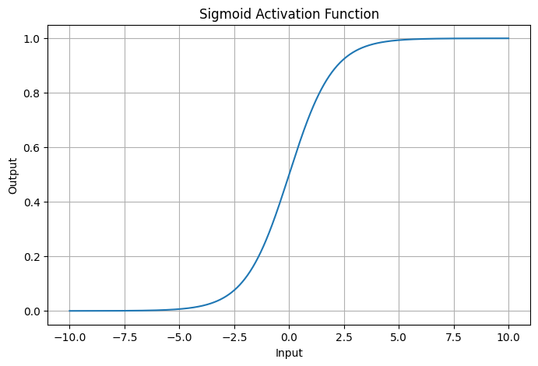
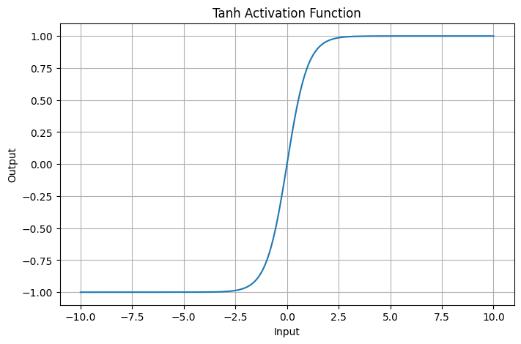
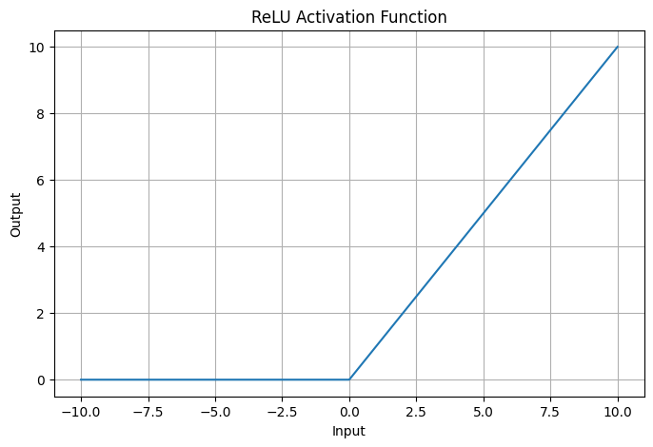
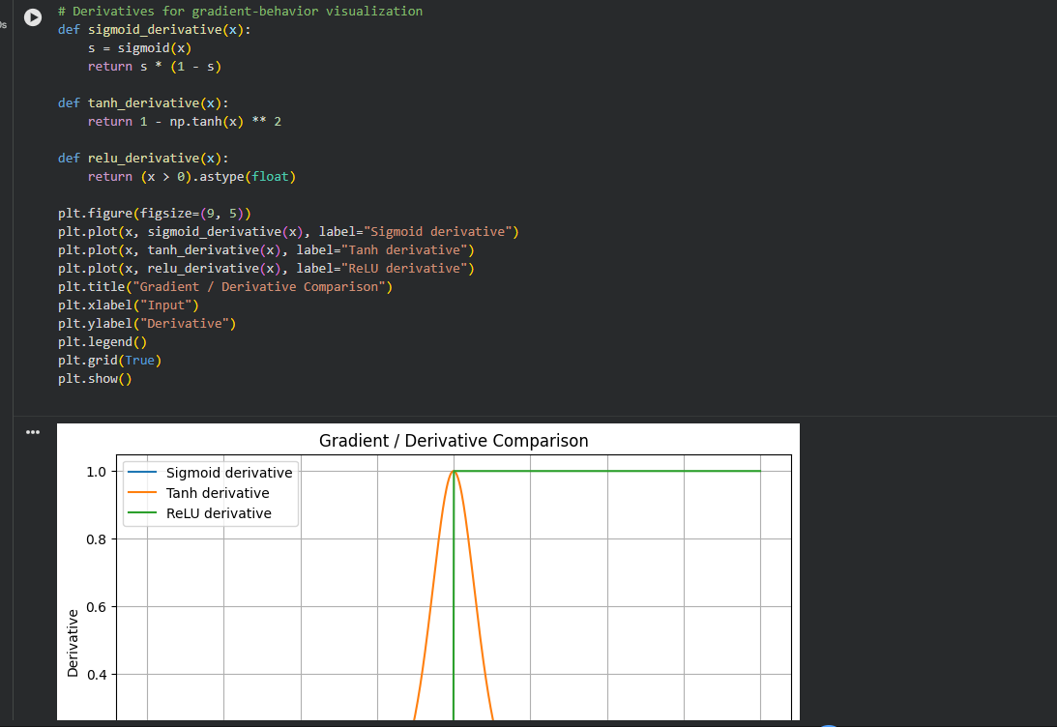

Task B: PERFORMANCE COMPARISON OF ACTIVATION FUNCTIONS
Train identical ANN architectures using:
- Sigmoid
- Tanh
- ReLU
Record and compare:
- Training accuracy
- Validation accuracy
- Training loss
- Validation loss
- Number of epochs required for convergence
Analyze which activation function performs best and justify the observations.

(CODE: CONATAINS STUDENT ROLL NOS
SCREENSHOT OF CODE
SCREENSHOT OF OUTPUT)

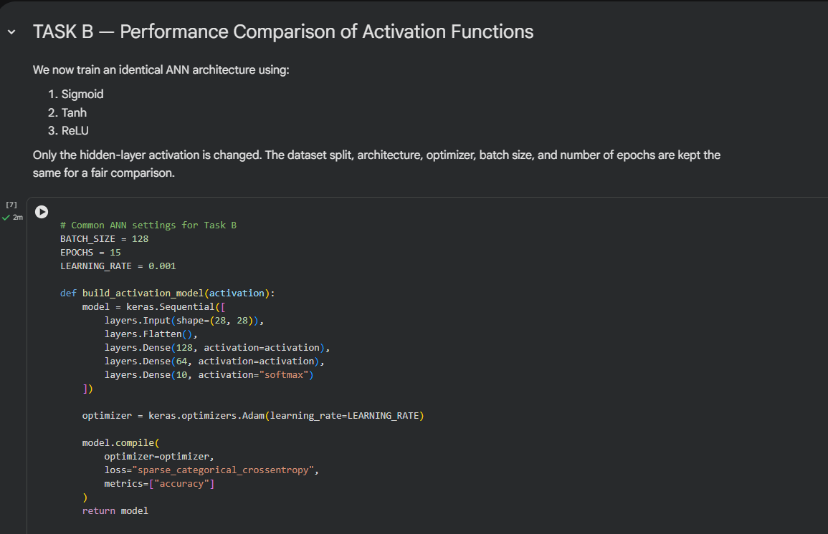

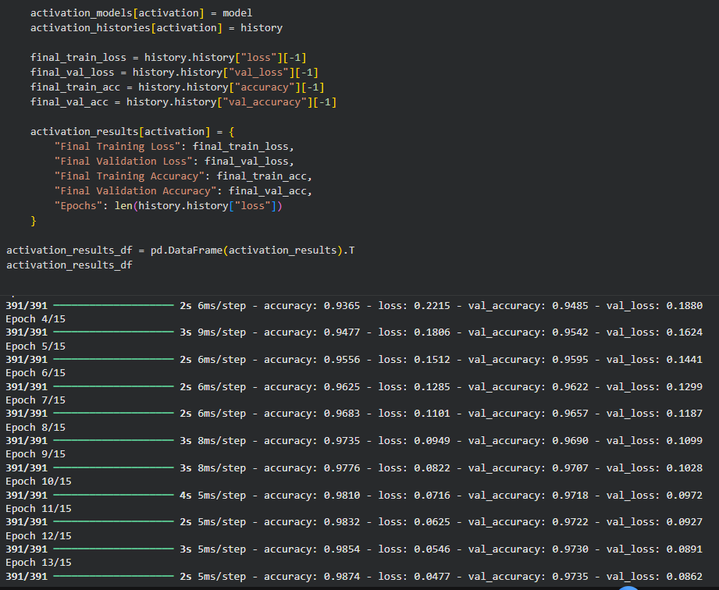

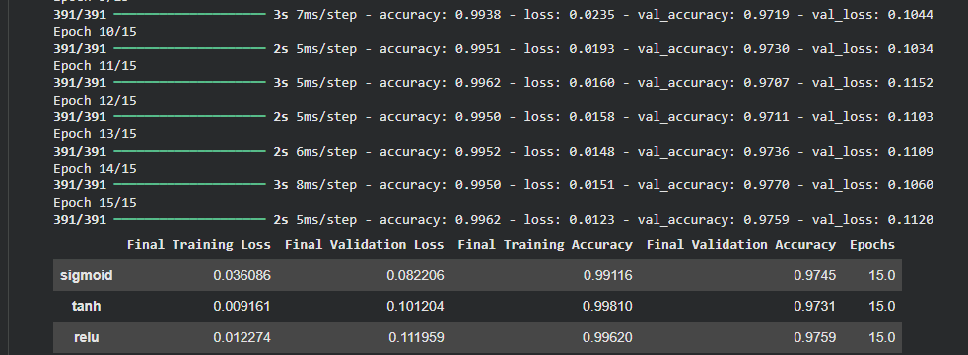

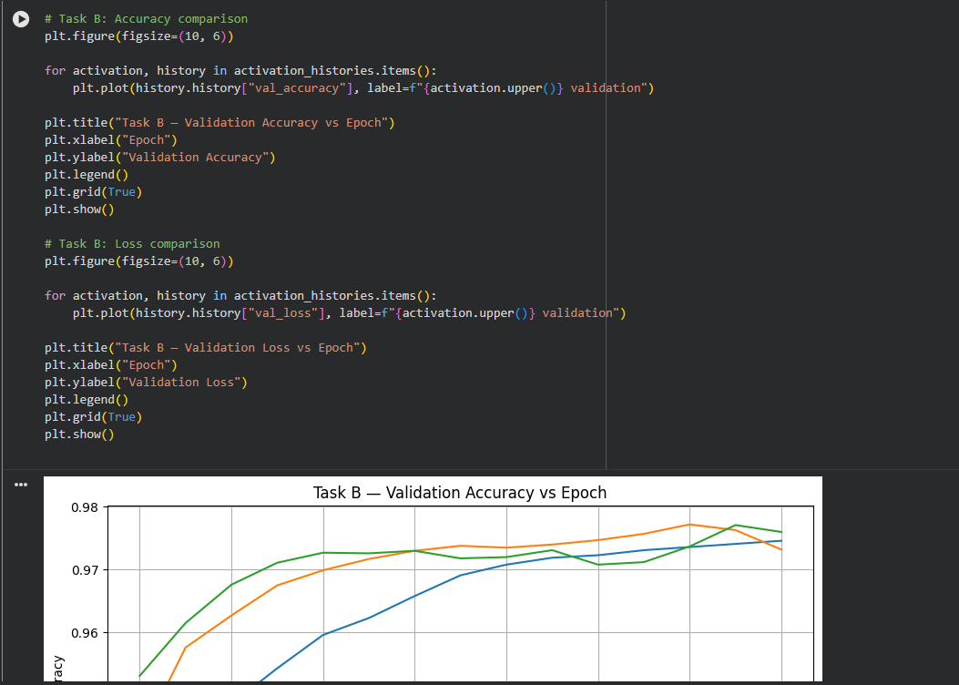
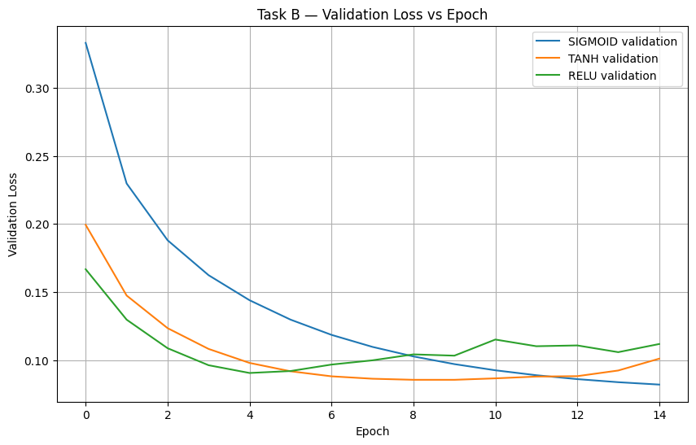

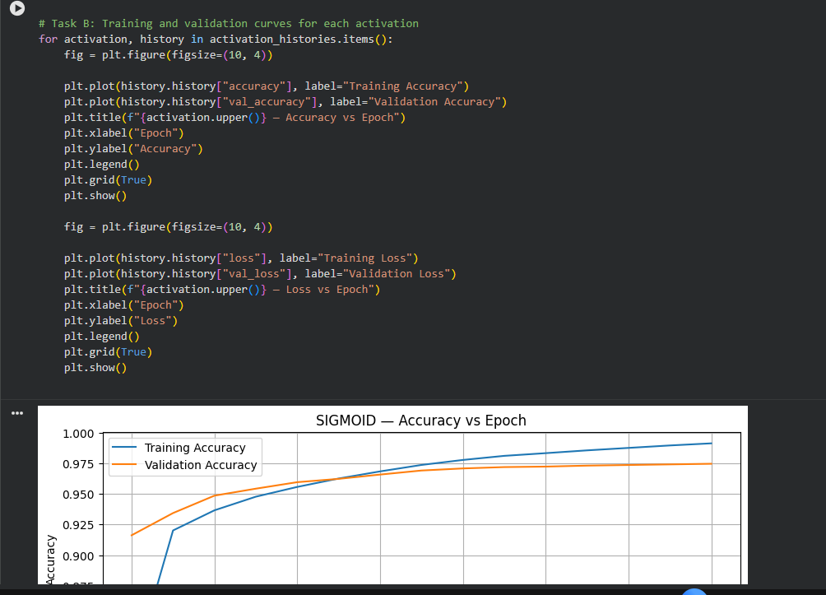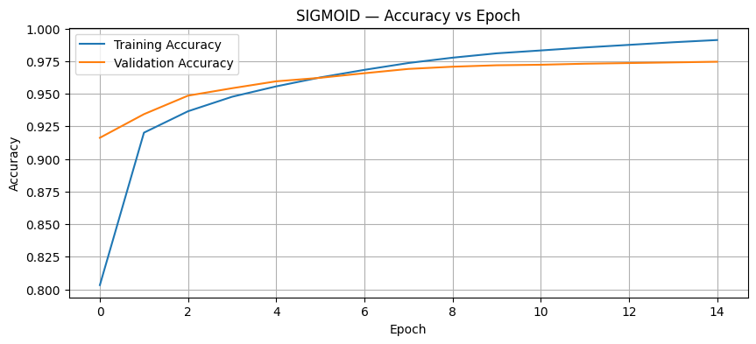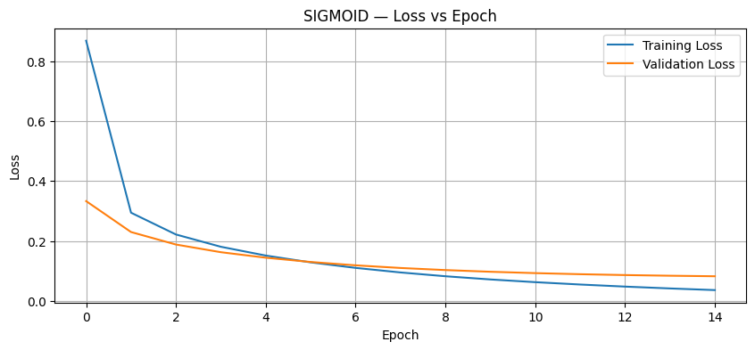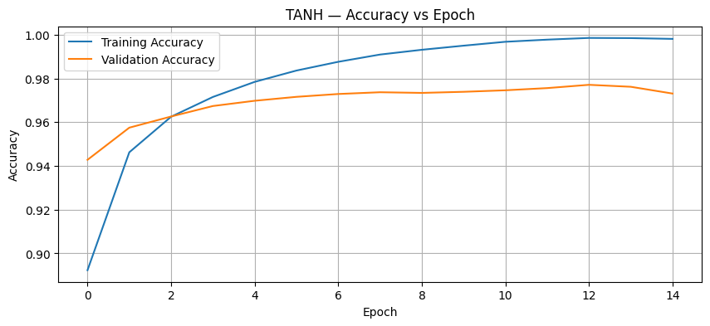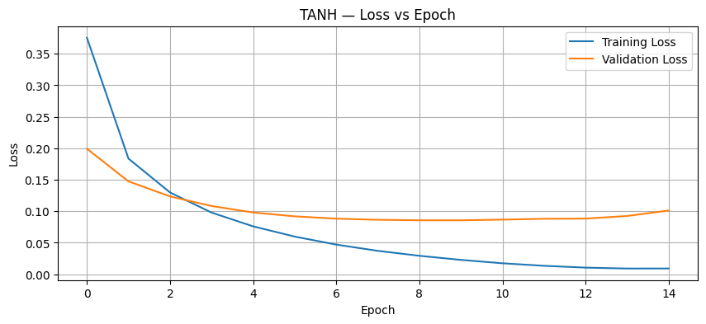

Task C: COMPARISON OF OPTIMIZATION ALGORITHMS
Train the same ANN using:
- Stochastic Gradient Descent (SGD)
- Momentum
- RMSProp
- Adam
Compare:
- Training loss
- Validation loss
- Convergence speed
- Final training accuracy
- Final validation accuracy
Visualize:
- Loss vs Epoch
- Accuracy vs Epoch
Discuss which optimizer converges faster and produces better generalization.

(CODE: CONATAINS STUDENT ROLL NOS
SCREENSHOT OF CODE
SCREENSHOT OF OUTPUT)

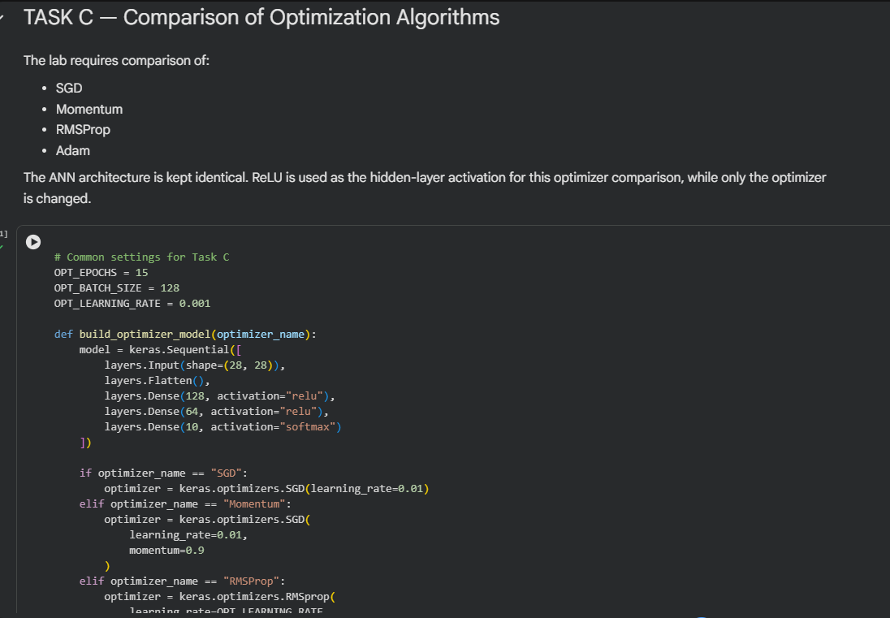
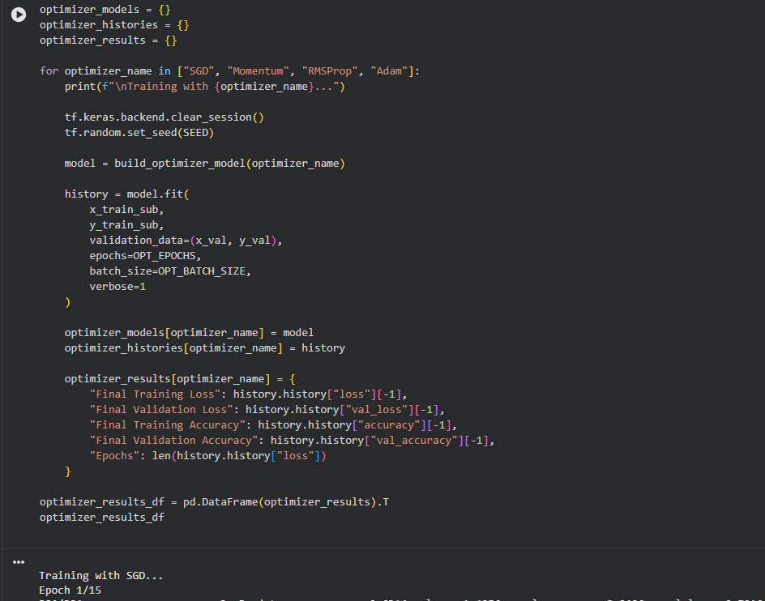

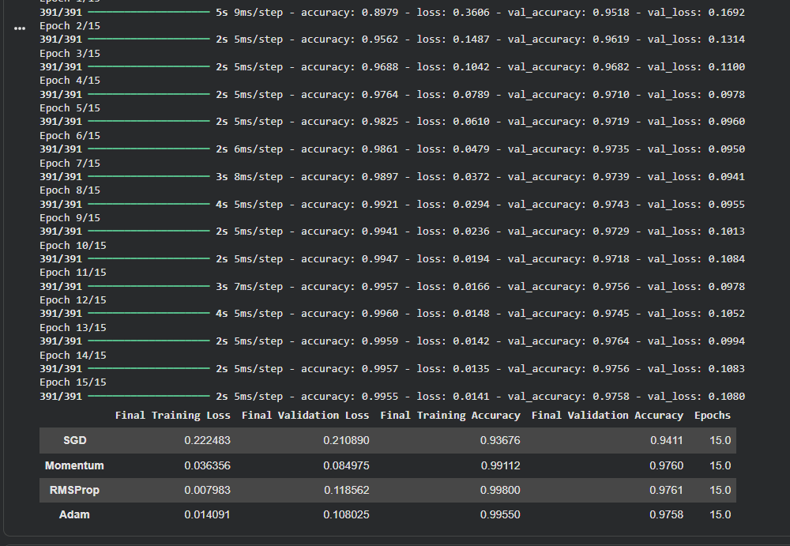

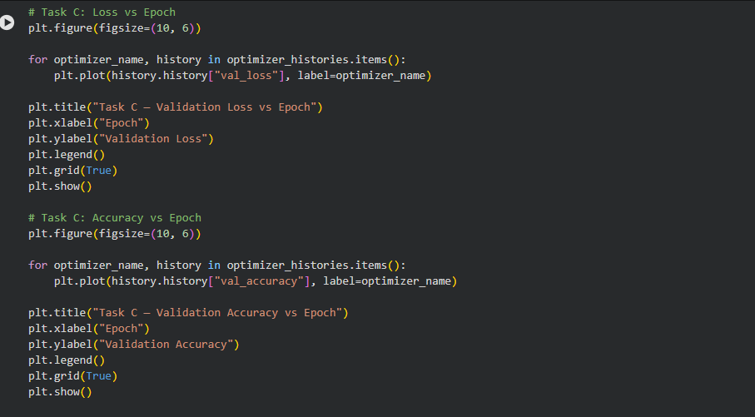
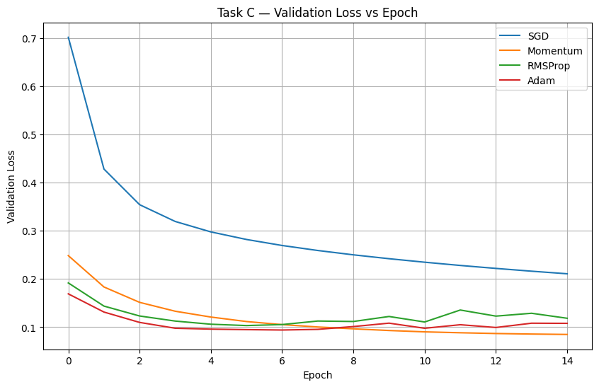
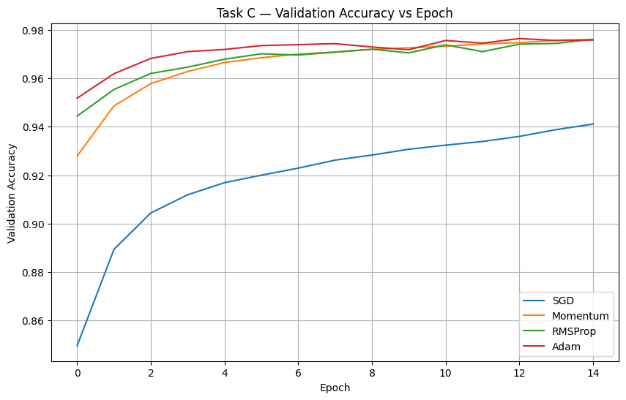

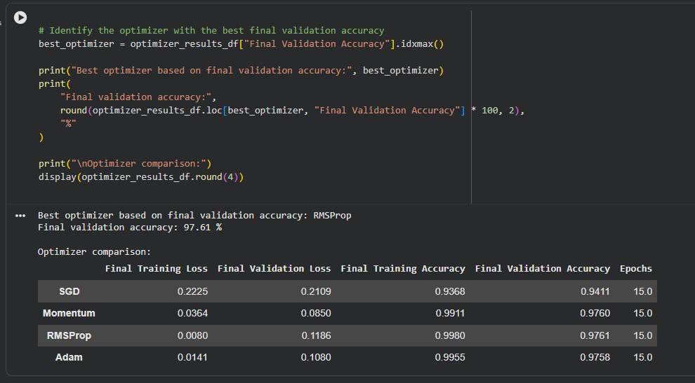

Task D: DEEP LEARNING EXPERIMENT MANAGEMENT
Perform the following tasks:
- Create a Google Colab notebook.
- Mount Google Drive.
- Save notebooks and trained models.
- Create a GitHub repository.
- Upload notebooks to GitHub.
- Commit changes and maintain version history using Git.
- Document the experiment using a README.md file.

(CODE: CONATAINS STUDENT ROLL NOS
SCREENSHOT OF CODE
SCREENSHOT OF OUTPUT)
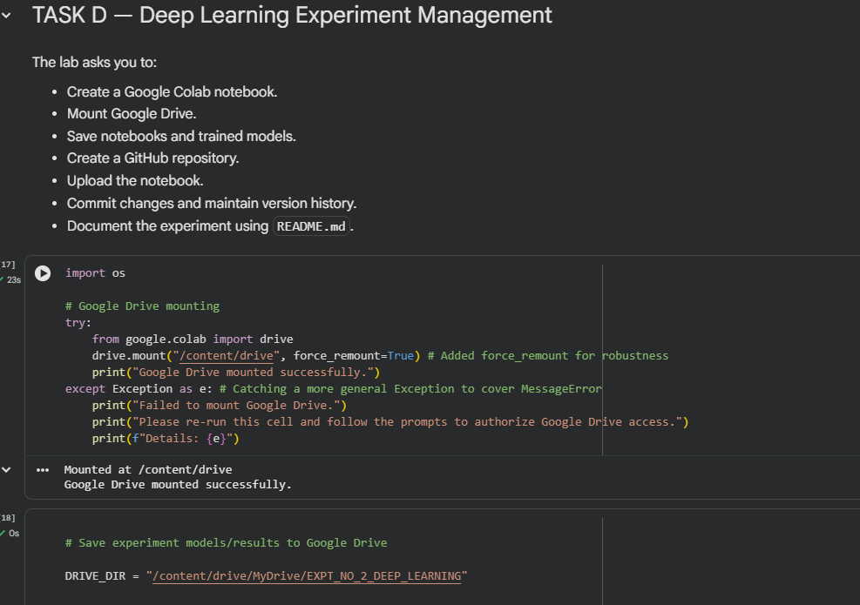

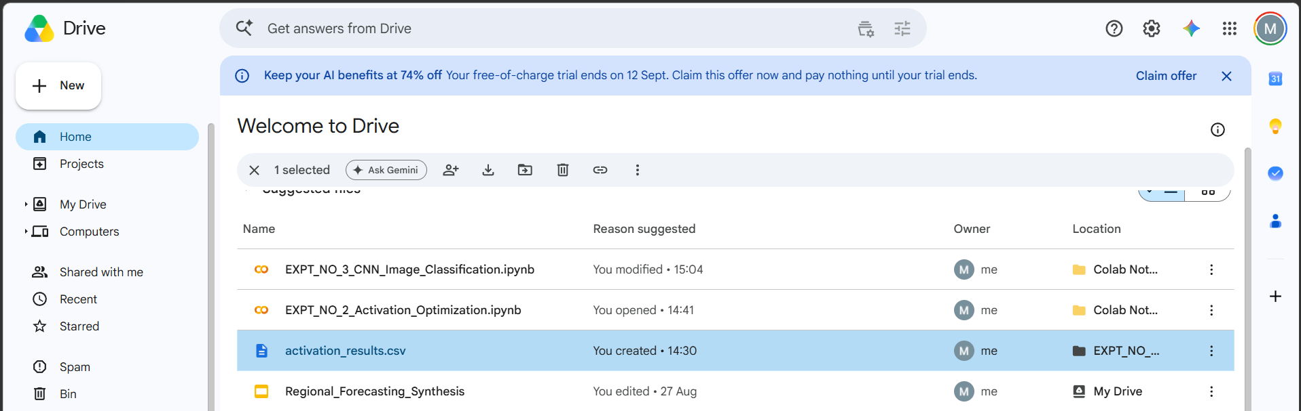

POST-LAB QUESTIONS (PROVIDE BRIEF ANSWERS TO THE FOLLOWING QUESTIONS)

- Which activation function achieved the best performance in your experiment? Justify your answer using the obtained results.
In this experiment, Sigmoid, Tanh, and ReLU activation functions were compared using the same ANN architecture and training conditions. The performance was evaluated using training accuracy, validation accuracy, training loss, validation loss, and convergence behavior. The activation function that achieved the highest validation accuracy can be considered the best performer for this experiment. ReLU generally provides faster training because it avoids strong saturation for positive inputs and maintains a useful gradient. The training and validation graphs also help us understand how quickly each activation function learned the patterns in the dataset. Therefore, the final conclusion should be based on the actual accuracy and loss values obtained during the experiment rather than selecting an activation function only from theoretical expectations.

- Compare the convergence behavior of SGD, Momentum, RMSProp, and Adam based on the training graphs.

Optimizer | Convergence | Main Feature
SGD | Slow | Simple weight updates
Momentum | Faster than SGD | Reduces fluctuations
RMSProp | Fast | Adaptive learning rate
Adam | Fast and stable | Combines momentum and adaptive learning

- Why does the ReLU activation function generally train faster than the Sigmoid activation function?

ReLU generally trains faster than Sigmoid because of the difference in their gradient behavior. ReLU produces zero for negative inputs and a linear output for positive inputs, so its gradient remains useful for positive values. Sigmoid produces values between 0 and 1 and becomes saturated when its input is very large or very small. In these saturated regions, the gradient becomes very small, which can slow down learning in deeper networks. ReLU therefore allows useful gradients to pass more effectively through the network during training. Because of this relu is faster

- How does version control using GitHub improve the reproducibility and collaboration of deep learning projects?

GitHub improves reproducibility by allowing the code and experiment files to be stored in a controlled version history. Each commit represents a particular stage of the project, making it possible to track changes made to the code. If an error is introduced later, earlier versions can be examined to understand what changed. GitHub also makes collaboration easier because multiple team members can access and work on the same project repository. Changes can be reviewed and combined instead of maintaining several unrelated copies of the project. Therefore, version control helps a deep-learning team maintain organized code, track experimental development, and reproduce earlier versions of the work.

- If you were asked to train a deep neural network for an image classification task, which activation function and optimizer would you choose? Justify your selection based on the experimental observations.
Component | Choice | Reason
Activation | ReLU | Faster training
Optimizer | Adam | Fast and adaptive
Output | Softmax | Multi-class classification

ASSESSMENT
Description | Max Marks | Marks Awarded
Pre Lab Exercise | 5
In Lab Exercise | 10
Post Lab Exercise | 5
Viva | 10
Total | 30
Faculty Signature

